|  |  |
| --- | --- |
|  | **FPT ACADEMY INTERNATIONAL**  **FPT – APTECH COMPUTER EDUCATION** |

**Centre Name: ACE-HCMC-2-FPT.**

**Address: 590 Cach Mang Thang 8, District 3, Ho Chi Minh City, Viet Nam.**

**ITM College**

User Guide

|  |  |  |  |
| --- | --- | --- | --- |
| **Center** | | ACE-HCMC-2-FPT | |
| **Instructor** | | Mr. Ngo Phuoc Nguyen | |
| **Class** | | T1.1908.E0 | |
| **Group** | | 1 | |
| **Group members** | | **Name** | **Student ID** |
| Vu Duc Huy | Student1215608 |
| Le Nguyen Minh Ngoc | Student1226455 |
| Huynh Quoc Huy | Student1208501 |
| Luong Vinh Hien | Student1204494 |
| **Assignment** | **Start date** | 28Dec2020 | |
| **End date** | 28Jan2021 | |

1. **Work Process**
2. **Guest (Front-End)**

Guest can use system for:

* Overall view about ITM College
* Apply for Admission
* View Department
* View Course
* View Faculty
* View Facilities
* Contact with ITM College
* Feedback to ITM College

1. **Admin (Back-End)**

Admin can use system to after login

* Overall view the website
  + Course Manager (View Course, Add Course, Edit Course, Disable or Active Course)
  + Department Manager (View Department, Add Department, Edit Department, Delete Department)
  + Faculty Manager (View Faculty, Add Faculty, Edit Faculty, Delete Faculty)

1. **Front-End (For Guest)**
2. **Home page**



|  |  |  |  |  |  |  |
| --- | --- | --- | --- | --- | --- | --- |
| Navigation | | | | | | |
| No. | Name | Type | Validation | Event | Description | Status |
| 1 | Home | Hyberlink |  | Click | URL to Home | Enable |
| 2 | Admission | Hyberlink |  | Click | URL to Admission | Enable |
| 3 | Admission Status | Hyberlink |  | Click | URL to check Status | Enable |
| 4 | Courses | Hyberlink |  | Click | URL to Courses | Enable |
| 5 | Department | Hyberlink |  | Click | URL to Departments | Enable |
| 6 | Facilities | Hyberlink |  | Click | URL to Facilities | Enable |
| 7 | Faculty | Hyberlink |  | Click | URL to Faculties | Enable |
| 8 | Contact | Hyberlink |  | Click | URL to Contact | Enable |
| 9 | Login | Hyberlink |  | Click | URL to Login | Enable |
| 10 | Creat new Account | Hyberlink |  | Click | URL to Register | Enable |

* At home page Guest can:
* Click Course in Navigation bar to view Course Page
* Click Admission in Navigation bar to apply ITM College or Registration to search Admission by ID already have
* Click Department in Navigation bar to view Department Page
* Click Faculty in Navigation bar to view Faculty Page
* Click Facility in Navigation bar to view Facility Page
* Click Contact in Navigation bar to view Contact us Page

1. **Course Page**



* At Course page Guest can:
  + Click Course on Navigation like Home Page

1. **Admission Page**

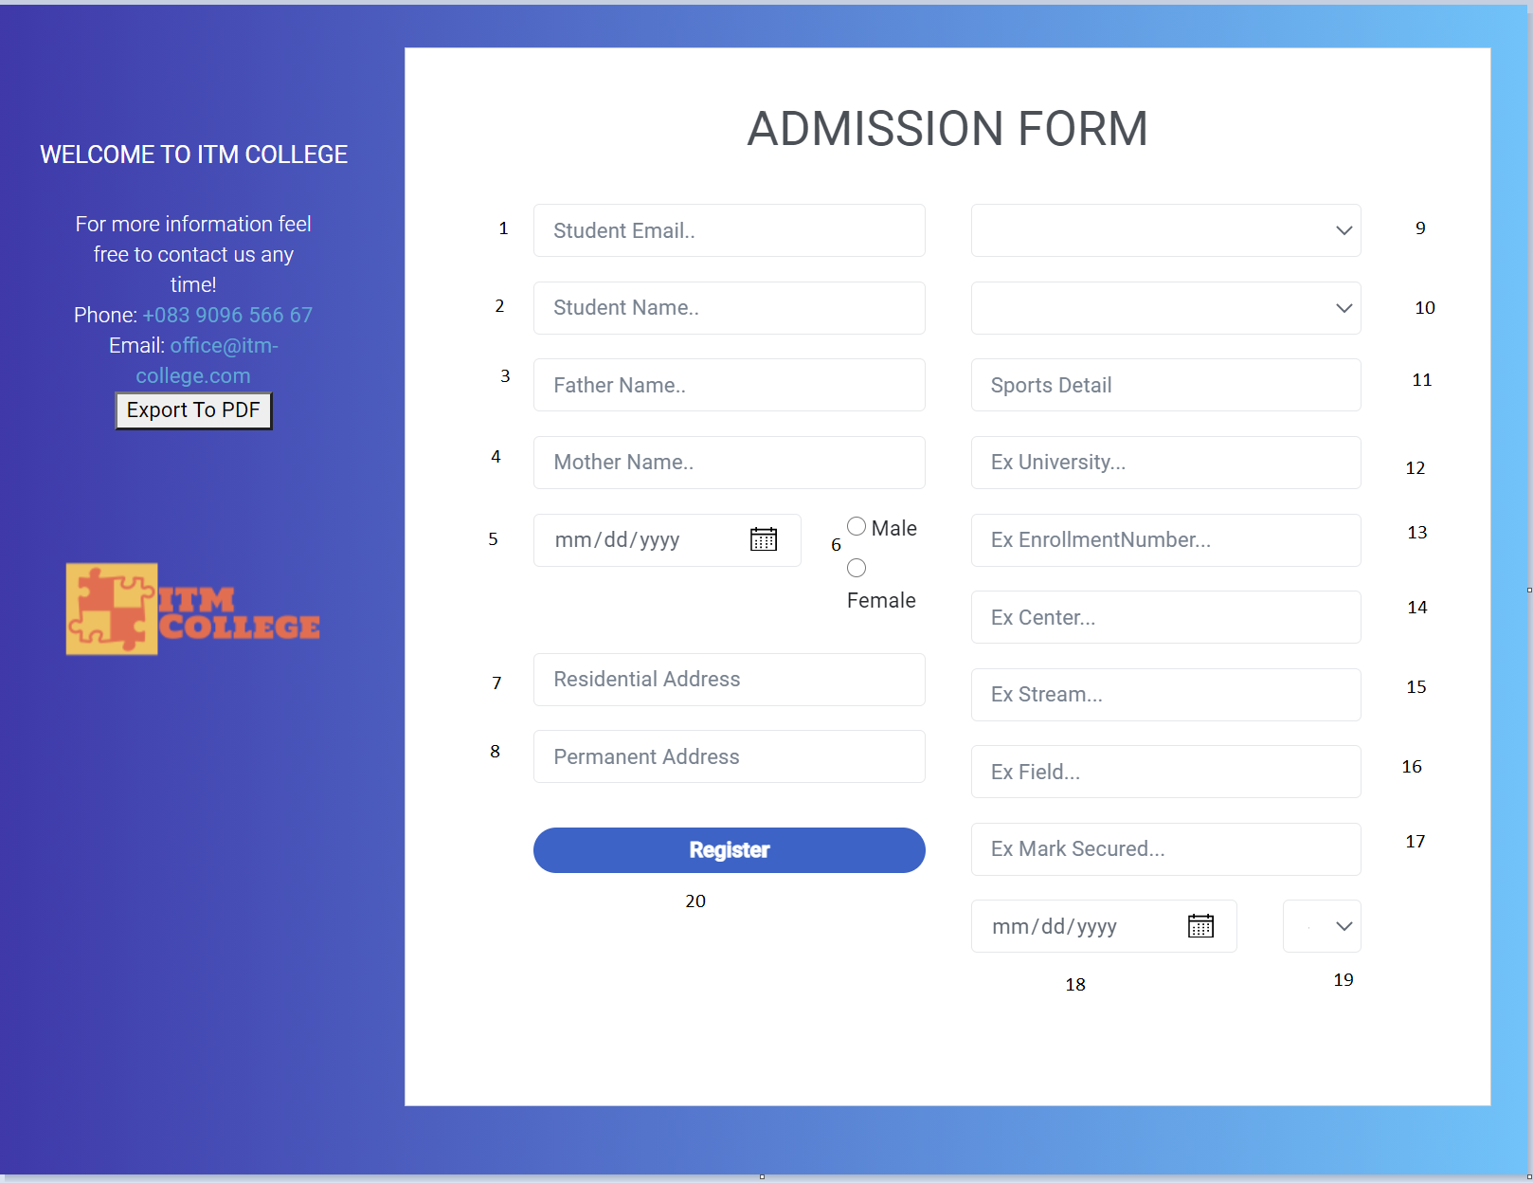

* At Admission page Guest can:
* Input full form Admission and click Register to Submit form
* Some fields are required, If some field invalid. A red message will show below each input text.

|  |  |  |  |  |  |  |
| --- | --- | --- | --- | --- | --- | --- |
| Admission Form | | | | | | |
| No | Name | Type | Validation | Event | Description | Status |
| 1 | StudentEmail | Text box |  | Input | Input student email | Enable |
| 2 | StudentName | Text box |  | Input | Input student name | Enable |
| 3 | FatherName | Text box |  | Input | Input father name | Enable |
| 4 | MotherName | Text box |  | Input | Input mother name | Enable |
| 5 | DoB | Text box |  | Input | Input date of birth | Enable |
| 6 | Gender | Radio |  | Click | Input gender | Enable |
| 7 | Residential Adress | Text box |  | Input | Input residential address | Enable |
| 8 | Permanent Adress | Text box |  | Input | Input permanent address | Enable |
| 9 | tbStream.Name | Text box |  | Select | Input stream name | Enable |
| 10 | tbField.Name | Text box |  | Select | Input field name | Enable |
| 11 | SportsDetails | Text box |  | Input | Input sports | Enable |
| 12 | ExUniversity | Text box |  | Input | Input previous university | Enable |
| 13 | ExEnrollmentNumber | Text box |  | Input | Input enrollment number (Previous Exam) | Enable |
| 14 | ExCenter | Text box |  | Input | Input center name (Previous Exam) | Enable |
| 15 | ExStream | Text box |  | Input | Input stream (Previous Exam) | Enable |
| 16 | ExField | Text box |  | Input | Input field  (Previous Exam) | Enable |
| 17 | ExMarkSecured | Text box |  | Input | Input mark secured  (Previous Exam) | Enable |
| 18 | OutOfDate | Text box |  | Input | Input out of date of previous exam | Enable |
| 19 | ClassObtained | Text box |  | Select | Input class obtained  (Previous Exam) | Enable |
| 20 | btnApply | Button |  | Click | Submit admission form | Enable |

1. **Department Page**

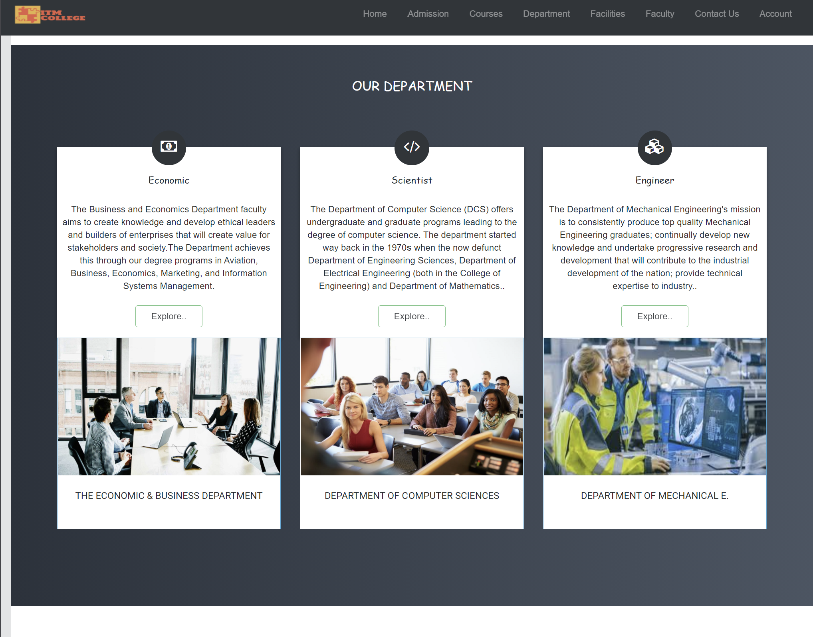

* At Department page Guest can:
  + Click Department on Navigation like Home page

1. **Faculty Page**

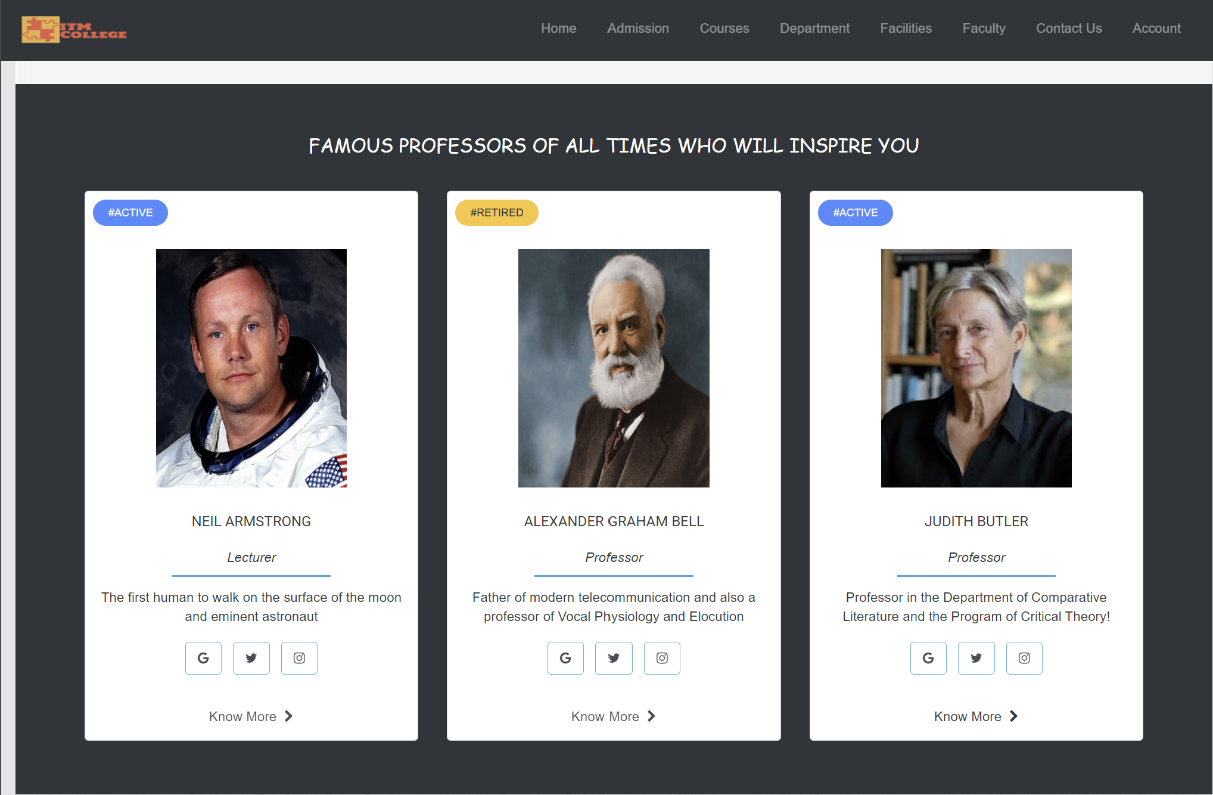

* At Faculty page Guest can:
  + Click Faculty on Navigation like Home page.

1. **Facility Page**

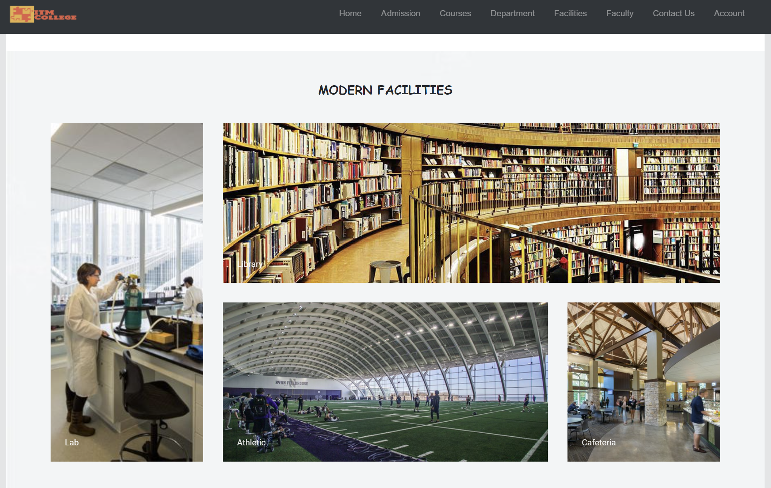

* At Facility page Guest can:
  + Click Facility on Navigation like Home page

1. **Contact Page**

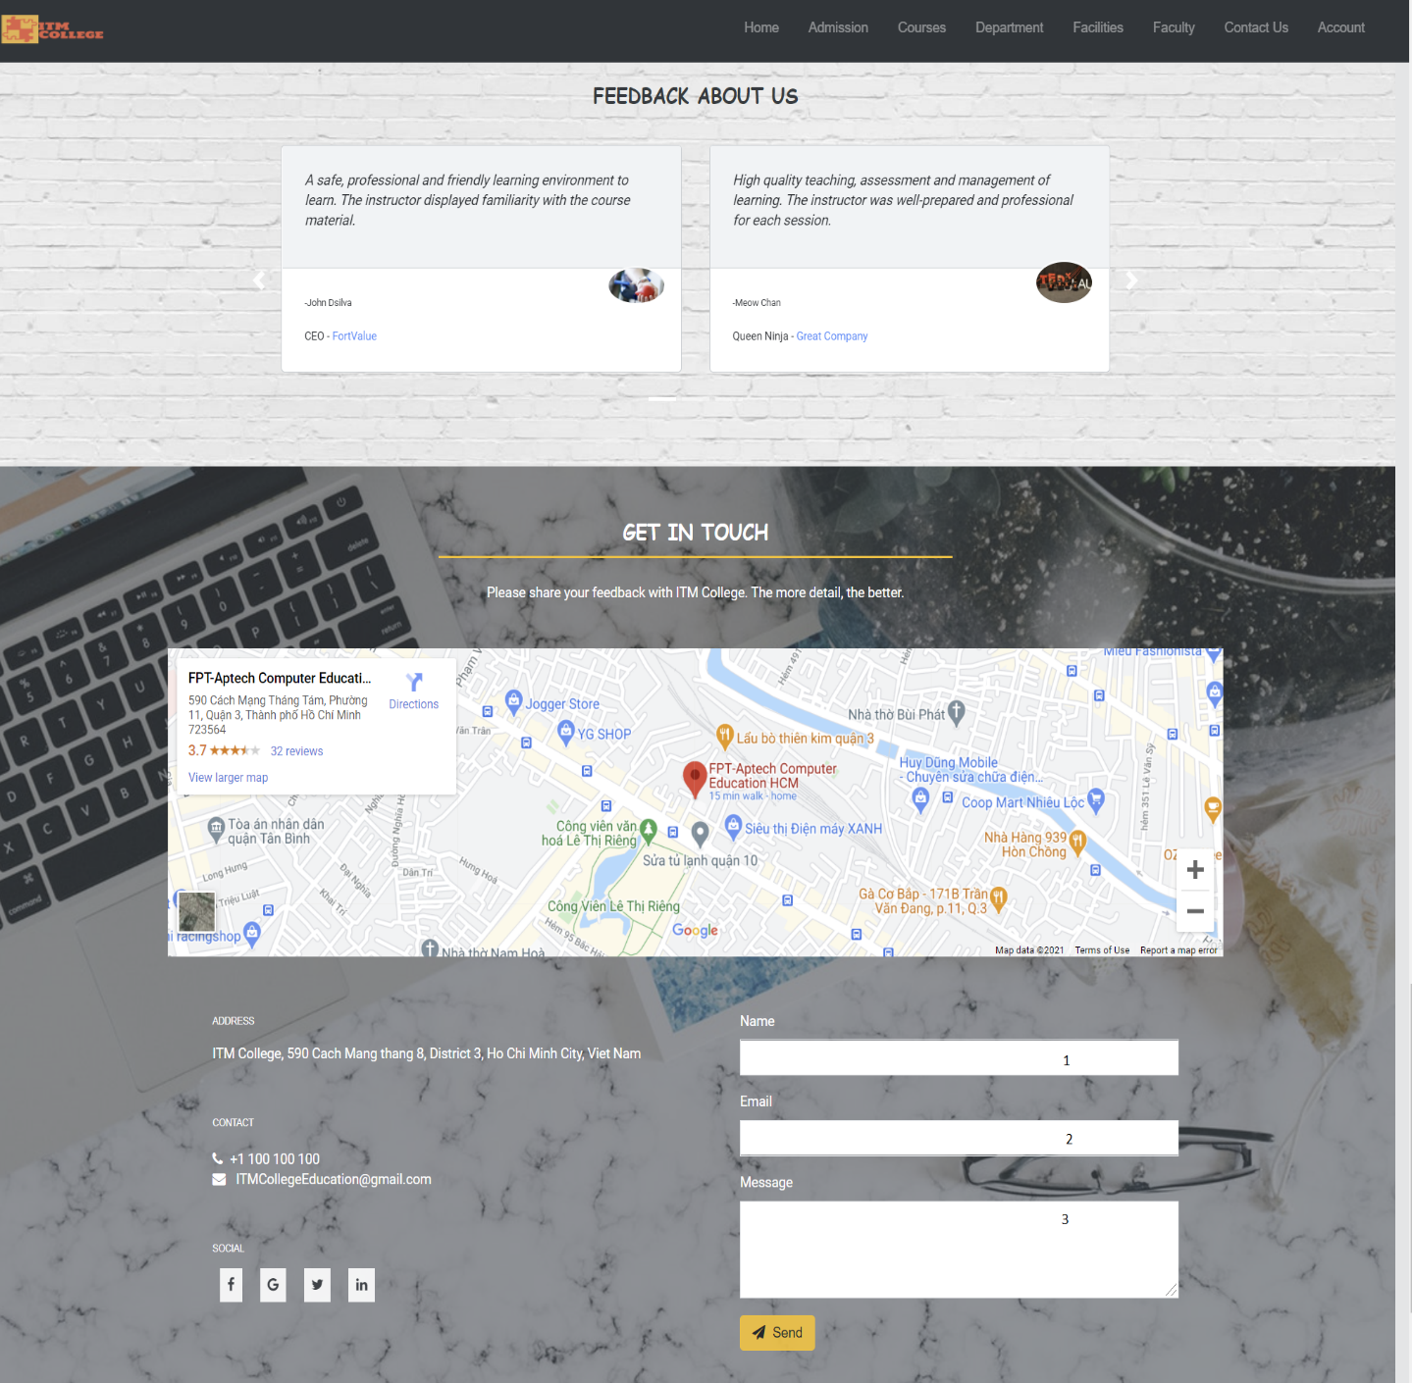

* At Contact page Guest can:
  + Click Contact on Navigation like Home page
  + Click on Map
  + Input full form Feedback and click Send to Submit form

|  |  |  |  |  |  |  |
| --- | --- | --- | --- | --- | --- | --- |
| Feedback Form | | | | | | |
| No | Name | Type | Validation | Event | Description | Status |
| 1 | Name | Text box | **Not Null** | Input | Input name/username | Enable |
| 2 | Email | Text box | **Not null** | input | Input Email | Enable |
| 3 | Message | Text box | **Not null** | Input | Input feedback content | Enable |
| 4 | Send | button |  | click | Button for submit form | Enable |

1. **Account Page**

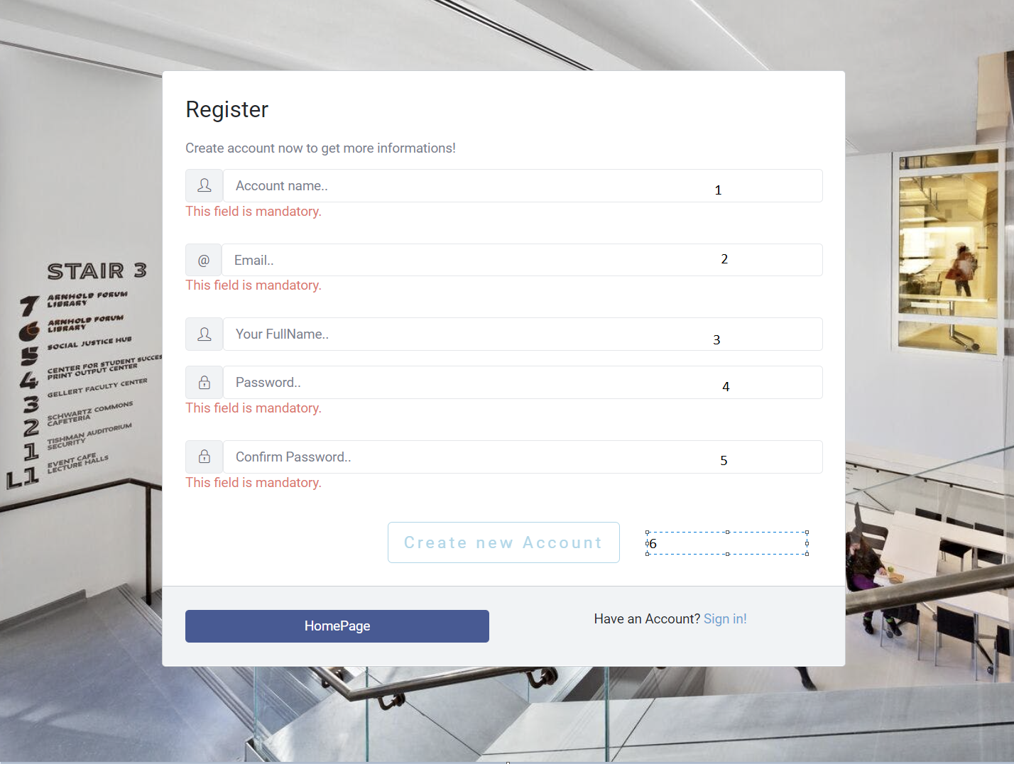

|  |  |  |  |  |  |  |
| --- | --- | --- | --- | --- | --- | --- |
| Registration Form | | | | | | |
| No | Name | Type | Validation | Event | Description | Status |
| 1 | username | Text box | **Required,**  **Unique** |  | Input User Name | Enable |
| 2 | Email | Text box | **Required,**  **Unique** |  | Input Email | Enable |
| 3 | FullName | Text box |  |  | Input Full Name | Enable |
| 4 | Password | Text box | **Required** |  | Input Password | Enable |
| 5 | ConfirmPassword | Text box | **Required** |  | Input Confirm Password | Enable |
| 6 | Create new Account | Button |  |  | Submit Form | Enable |

1. **Login**

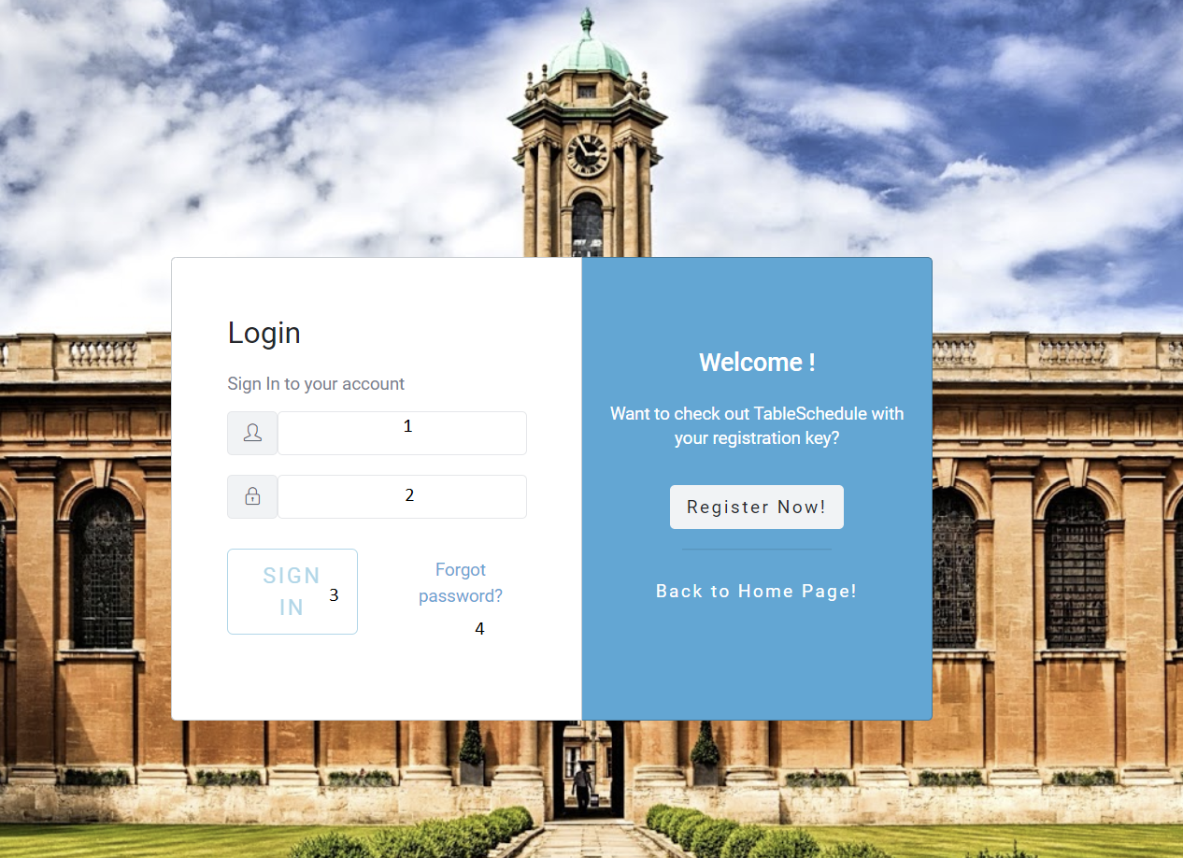

|  |  |  |  |  |  |  |
| --- | --- | --- | --- | --- | --- | --- |
| Login Form | | | | | | |
| No | Name | Type | Validation | Event | Description | Status |
| 1 | UserName | input |  | input | Input username | Enable |
| 2 | Password | input |  | input | Input password | Enable |
| 3 | Sign in | button |  | click | Submit Form | Enable |
| 4 | Forgot password | Hyberlink |  | click | To ForgotPassword | Enable |

1. **Back-End (For Admin)**
2. **Login**

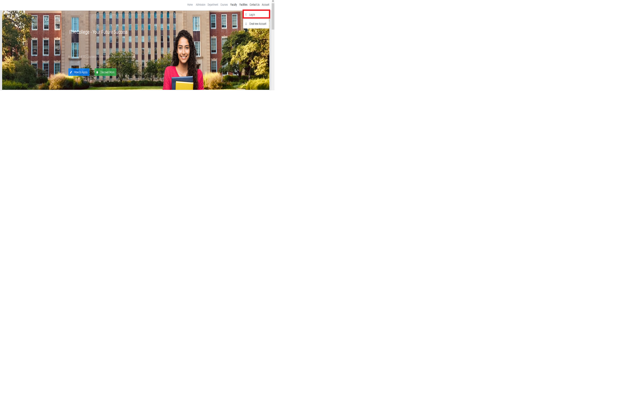

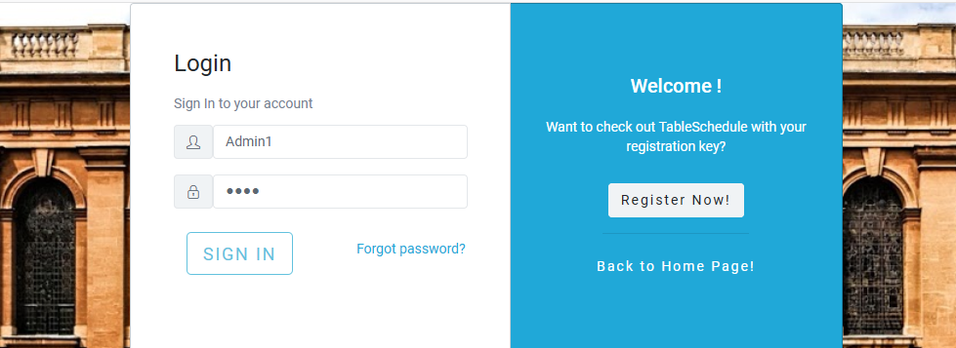

* Input ID and Password to Login

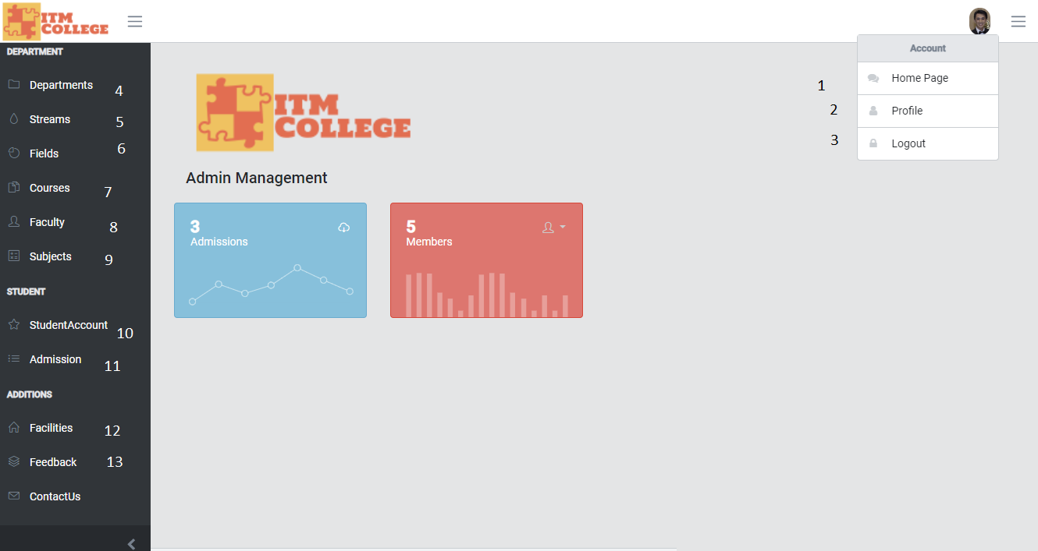

|  |  |  |  |  |  |  |
| --- | --- | --- | --- | --- | --- | --- |
| Navigation | | | | | | |
| No | Name | Type | Validation | Event | Description | Status |
| 1 | HomePage | HyperLink |  |  | Url to HomePage | Enable |
| 2 | Profile | HyperLink |  |  | Url to Page User | Enable |
| 3 | Log Out | Button |  | **Click** | Logout Admin – Delete Token | Enable |
| 4 | Departments | HyperLink |  |  | Url to Departments | Enable |
| 5 | Streams | HyperLink |  |  | Url to Streams | Enable |
| 6 | Fields | HyperLink |  |  | Url to Fields | Enable |
| 7 | Courses | HyperLink |  |  | Url to Courses | Enable |
| 8 | Faculty | HyperLink |  |  | Url to Faculty | Enable |
| 9 | Subjects | HyperLink |  |  | Url to Subjects | Enable |
| 10 | StudentAccount | HyperLink |  |  | Url to StudentAccount | Enable |
| 11 | Admission | HyperLink |  |  | Url to Admission | Enable |
| 12 | Facilities | HyperLink |  |  | Url to Facilities | Enable |
| 13 | Feedback | HyperLink |  |  | Url to Feedback | Enable |

**View of ITM’s Administrator**

1. Course Management
2. Course List

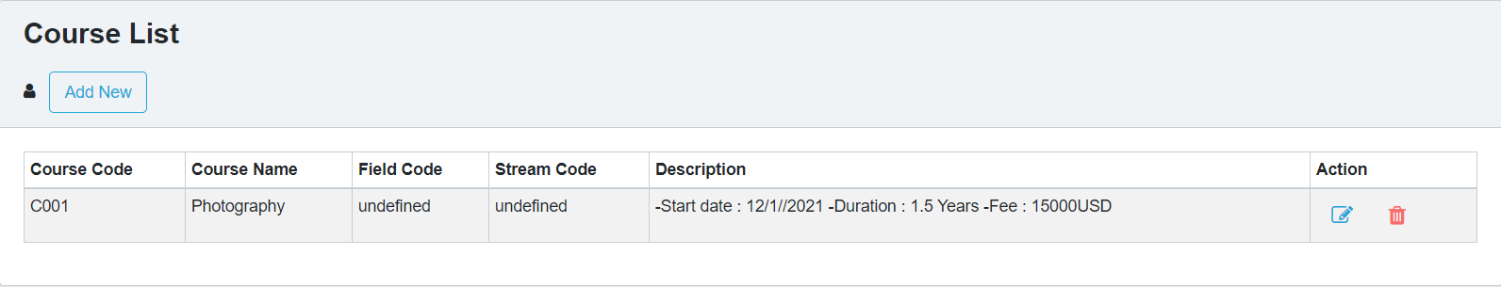

|  |  |  |  |  |  |  |
| --- | --- | --- | --- | --- | --- | --- |
| Course List | | | | | | |
| No. | Name | Type | Validation | Event | Description | Status |
| 1 | Add New | Hyberlink |  | Click | Create new Course | Enable |
| 2 | btnEdit | Button |  | Click | Edit Course | Enable |
| 3 | btnDelete | Button |  | Click | Delete Course | Enable |

1. Course Add

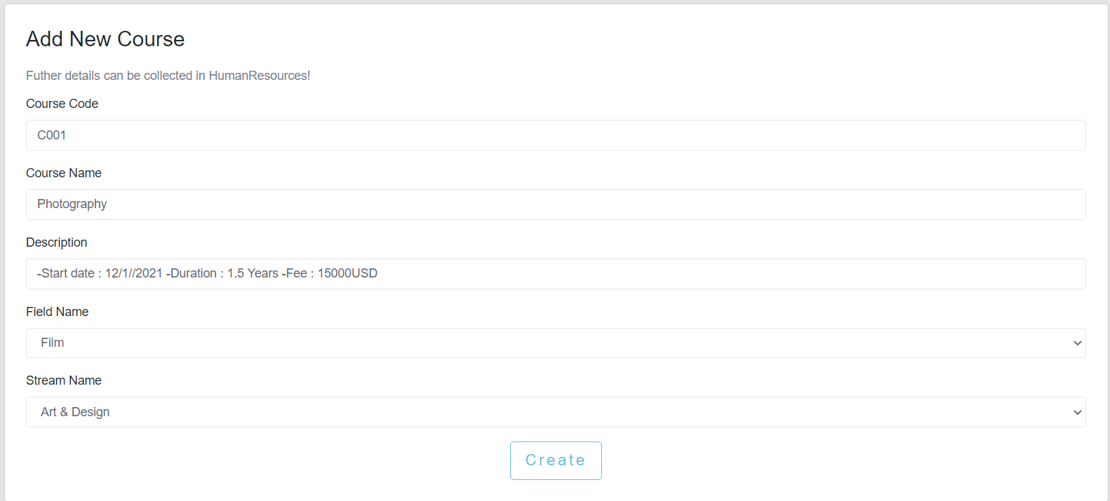

|  |  |  |  |  |  |  |
| --- | --- | --- | --- | --- | --- | --- |
| Create Course Post | | | | | | |
| No. | Name | Type | Validation | Event | Description | Status |
| 1 | CourseCode | TextField | 0 <= Length <= 30 | Input | Input Course ID | Enable |
| 2 | Course Name | TextField | 0 <= Length <= 50 | Input | Input Course Name | Enable |
| 3 | Description | TextField |  | Input | About Course | Enable |
| 4 | Stream Name | Dropdown |  | Click | Choose Stream for Course | Enable |
| 5 | Field Name | Dropdown |  | Click | Choose Field for Course | Enable |
| 6 | btnCreate | Button |  | Click | Submit form Create | Enable |

1. Course Edit

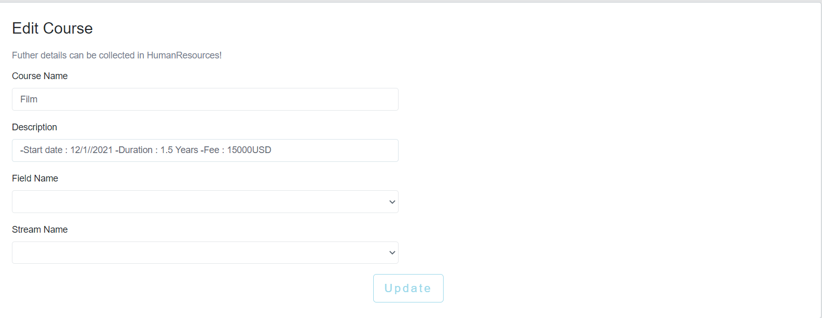

|  |  |  |  |  |  |  |
| --- | --- | --- | --- | --- | --- | --- |
| Edit Course Post | | | | | | |
| No. | Name | Type | Validation | Event | Description | Status |
| 1 | Course Name | TextField | 0 <= Length <= 50 | Input | Input Course Name | Enable |
| 2 | Description | TextField |  | Input | About Course | Enable |
| 3 | Stream Name | Dropdown |  | Click | Choose Stream for Course | Enable |
| 4 | Field Name | Dropdown |  | Click | Choose Field for Course | Enable |
| 5 | btnUpdate | Button |  | Click | Submit form Edit | Enable |

Field Management

1. Field list

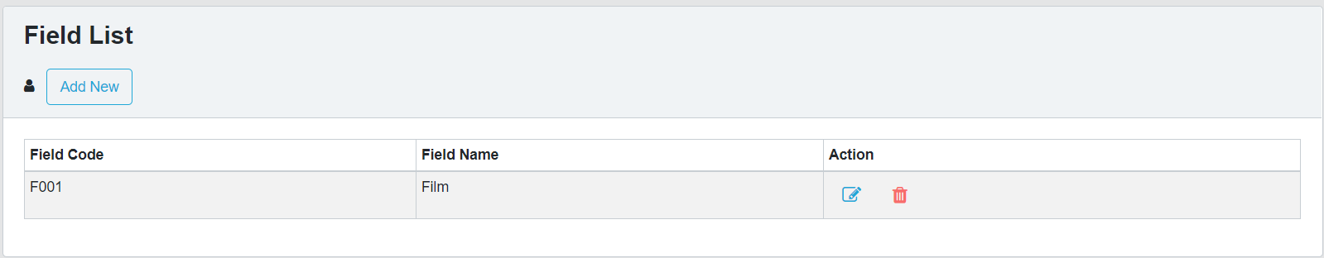

|  |  |  |  |  |  |  |
| --- | --- | --- | --- | --- | --- | --- |
| Field List | | | | | | |
| No. | Name | Type | Validation | Event | Description | Status |
| 1 | Add New | Hyberlink |  | Click | Create new Field | Enable |
| 3 | btnEdit | Button |  | Click | Edit Field | Enable |
| 4 | btnDelete | Button |  | Click | Delete Field | Enable |

1. Field Add

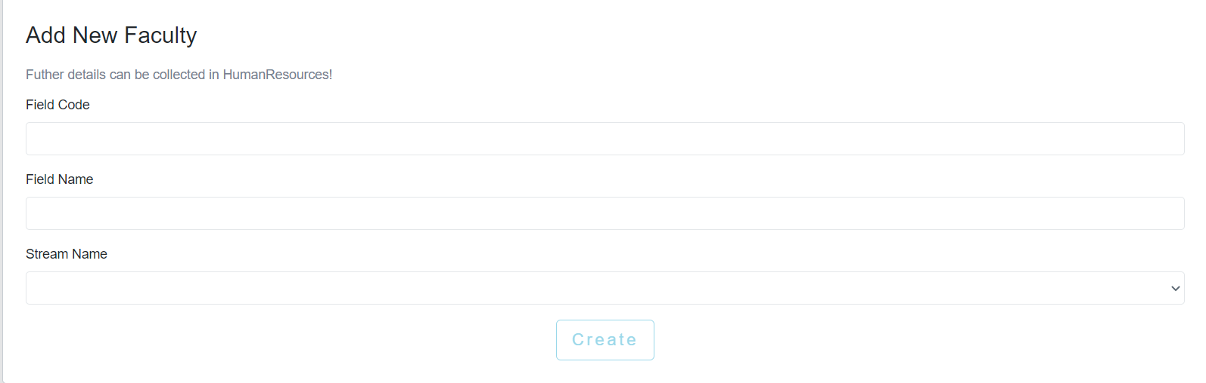

1. Field Edit

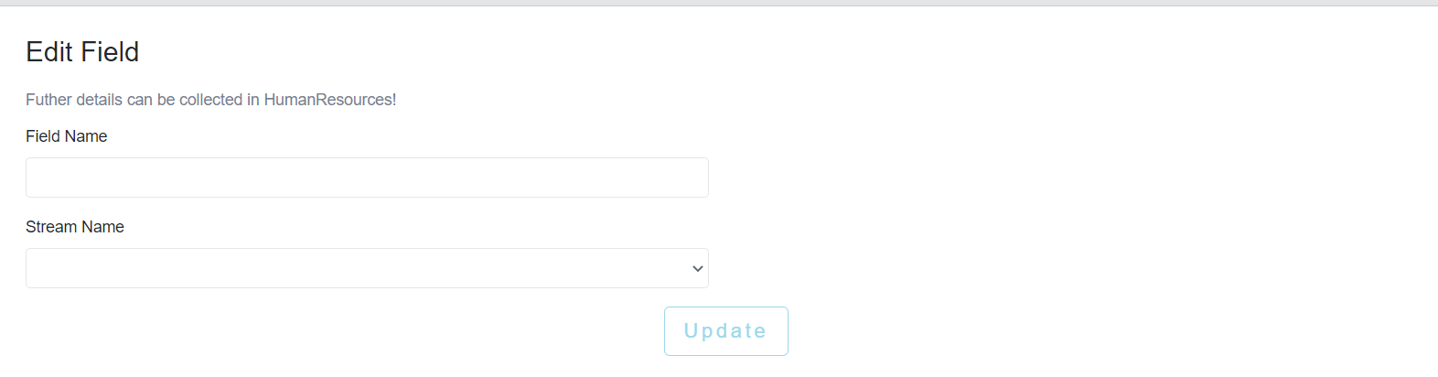

|  |  |  |  |  |  |  |
| --- | --- | --- | --- | --- | --- | --- |
| Edit Field Post | | | | | | |
| No. | Name | Type | Validation | Event | Description | Status |
| 1 | Field Name | TextField | 0 <= Length <= 50 | Input | Input Field Name | Enable |
| 2 | Stream Name | Dropdown |  | Click | Choose Stream for Course | Enable |
| 3 | btnUpdate | Button |  | Click | Submit form Edit | Enable |

1. Subject Management
2. Subject List

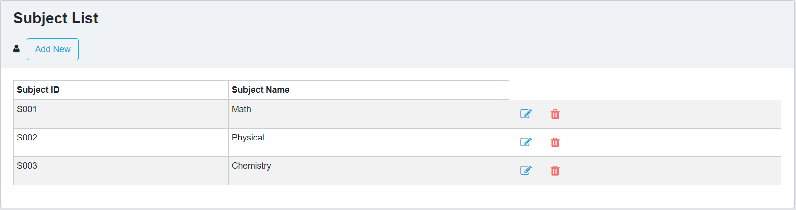

|  |  |  |  |  |  |  |
| --- | --- | --- | --- | --- | --- | --- |
| Subject List | | | | | | |
| No. | Name | Type | Validation | Event | Description | Status |
| 1 | Add New | Hyberlink |  | Click | Create new Subject | Enable |
| 2 | btnEdit | Button |  | Click | Edit Subject | Enable |
| 3 | btnDelete | Button |  | Click | Delete Subject | Enable |

1. Subject Add

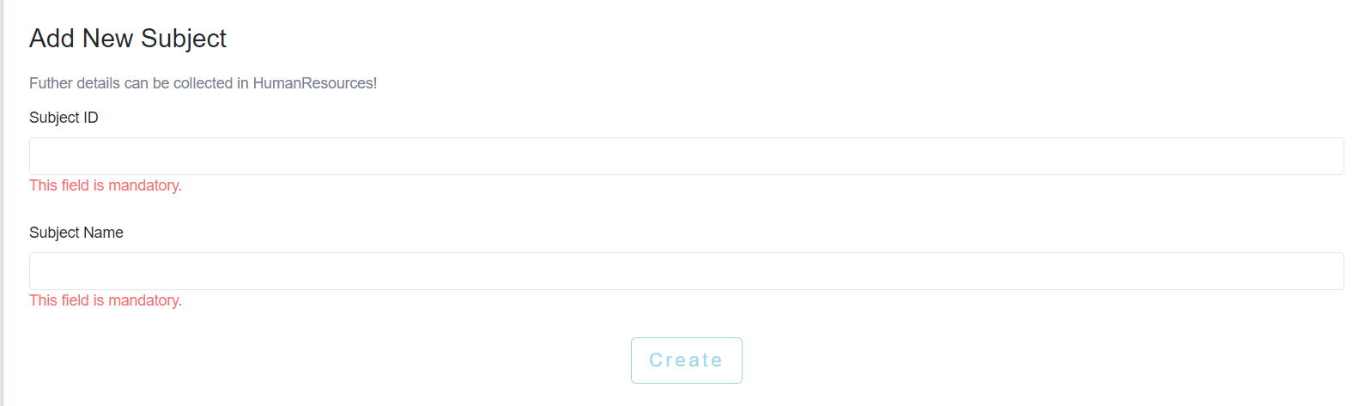

|  |  |  |  |  |  |  |
| --- | --- | --- | --- | --- | --- | --- |
| Create Course Post | | | | | | |
| No. | Name | Type | Validation | Event | Description | Status |
| 1 | Subject Code | TextField | 0 <= Length <= 30 | Input | Input Subject ID | Enable |
| 2 | Subject Name | TextField | 0 <= Length <= 50 | Input | Input Subject Name | Enable |
| 3 | btnCreate | Button |  | clieck | Submit form Create | Enable |

1. Subject Edit

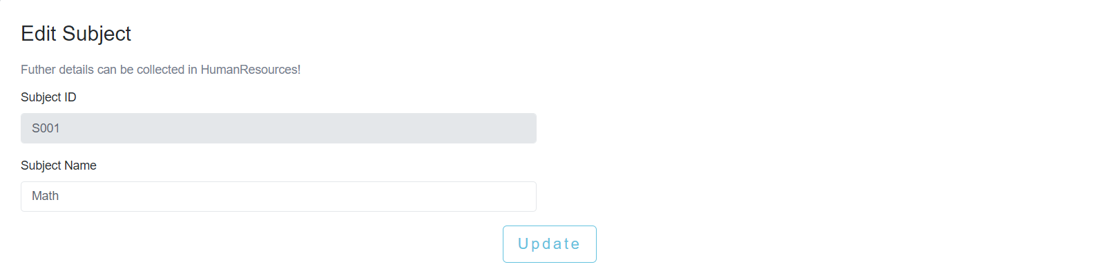

|  |  |  |  |  |  |  |
| --- | --- | --- | --- | --- | --- | --- |
| Edit Field Post | | | | | | |
| No. | Name | Type | Validation | Event | Description | Status |
| 1 | Subject Name | TextField | 0 <= Length <= 50 | Input | Input Subject Name | Enable |
|  |  |  |  |  |  |  |
| 2 | btnUpdate | Button |  | Click | Submit form Edit | Enable |

1. Faculty Management
2. Faculty Add

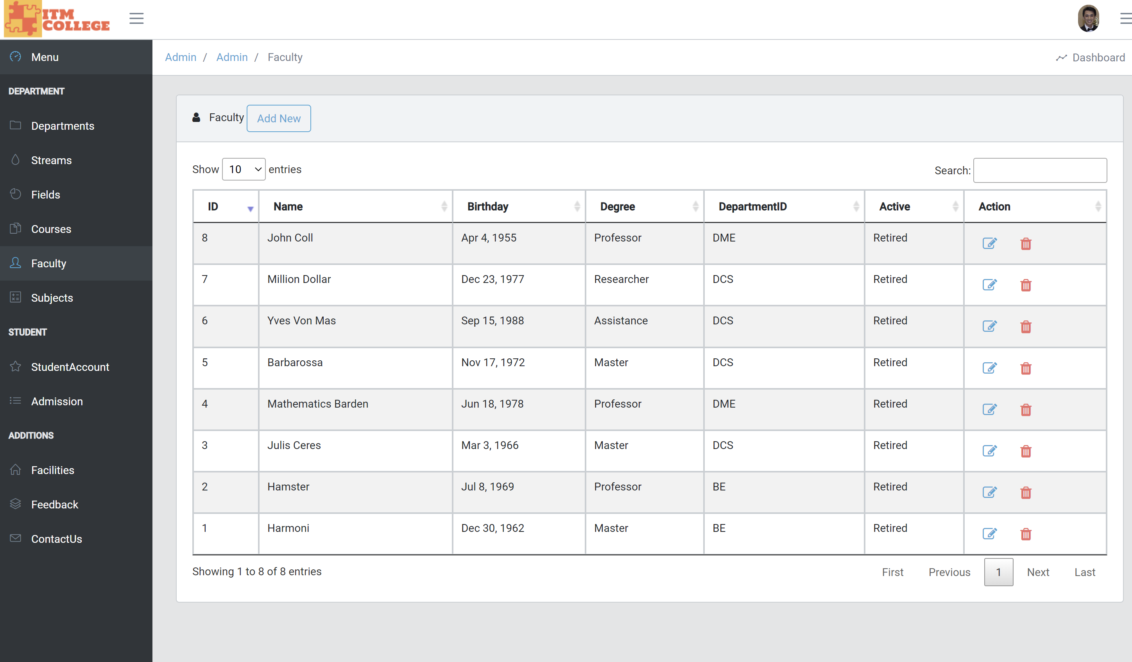

1. Faculty Add

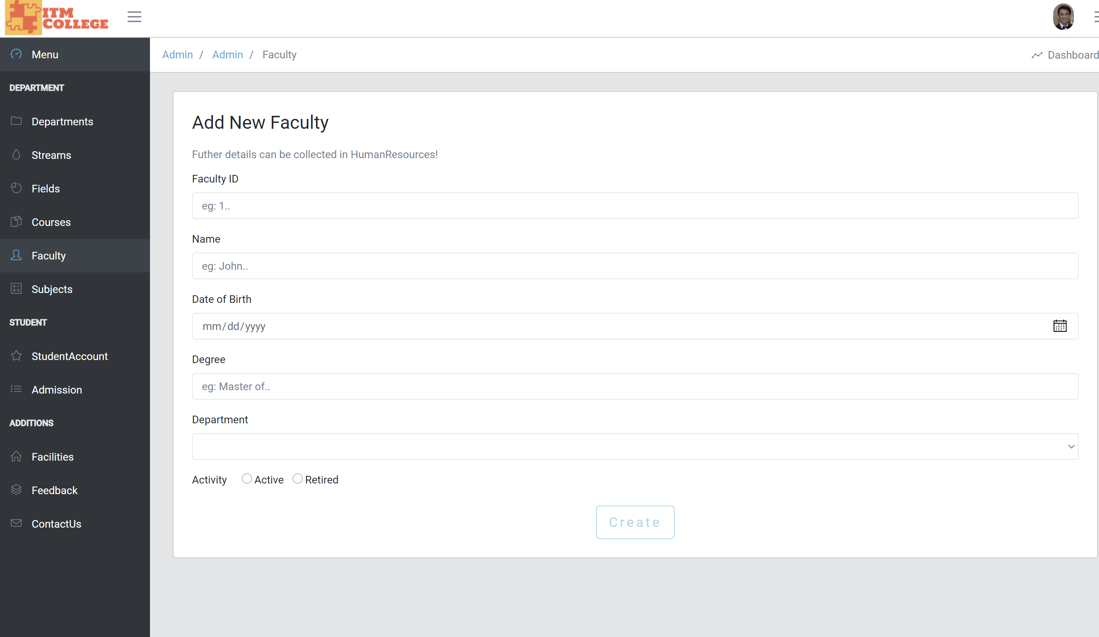

1. Faculty Edit

(Upload Profile optional)

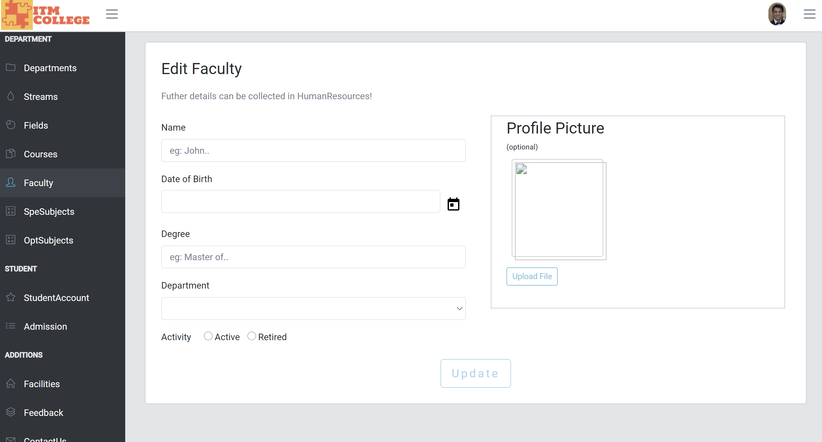

1. Department Management
2. Department List

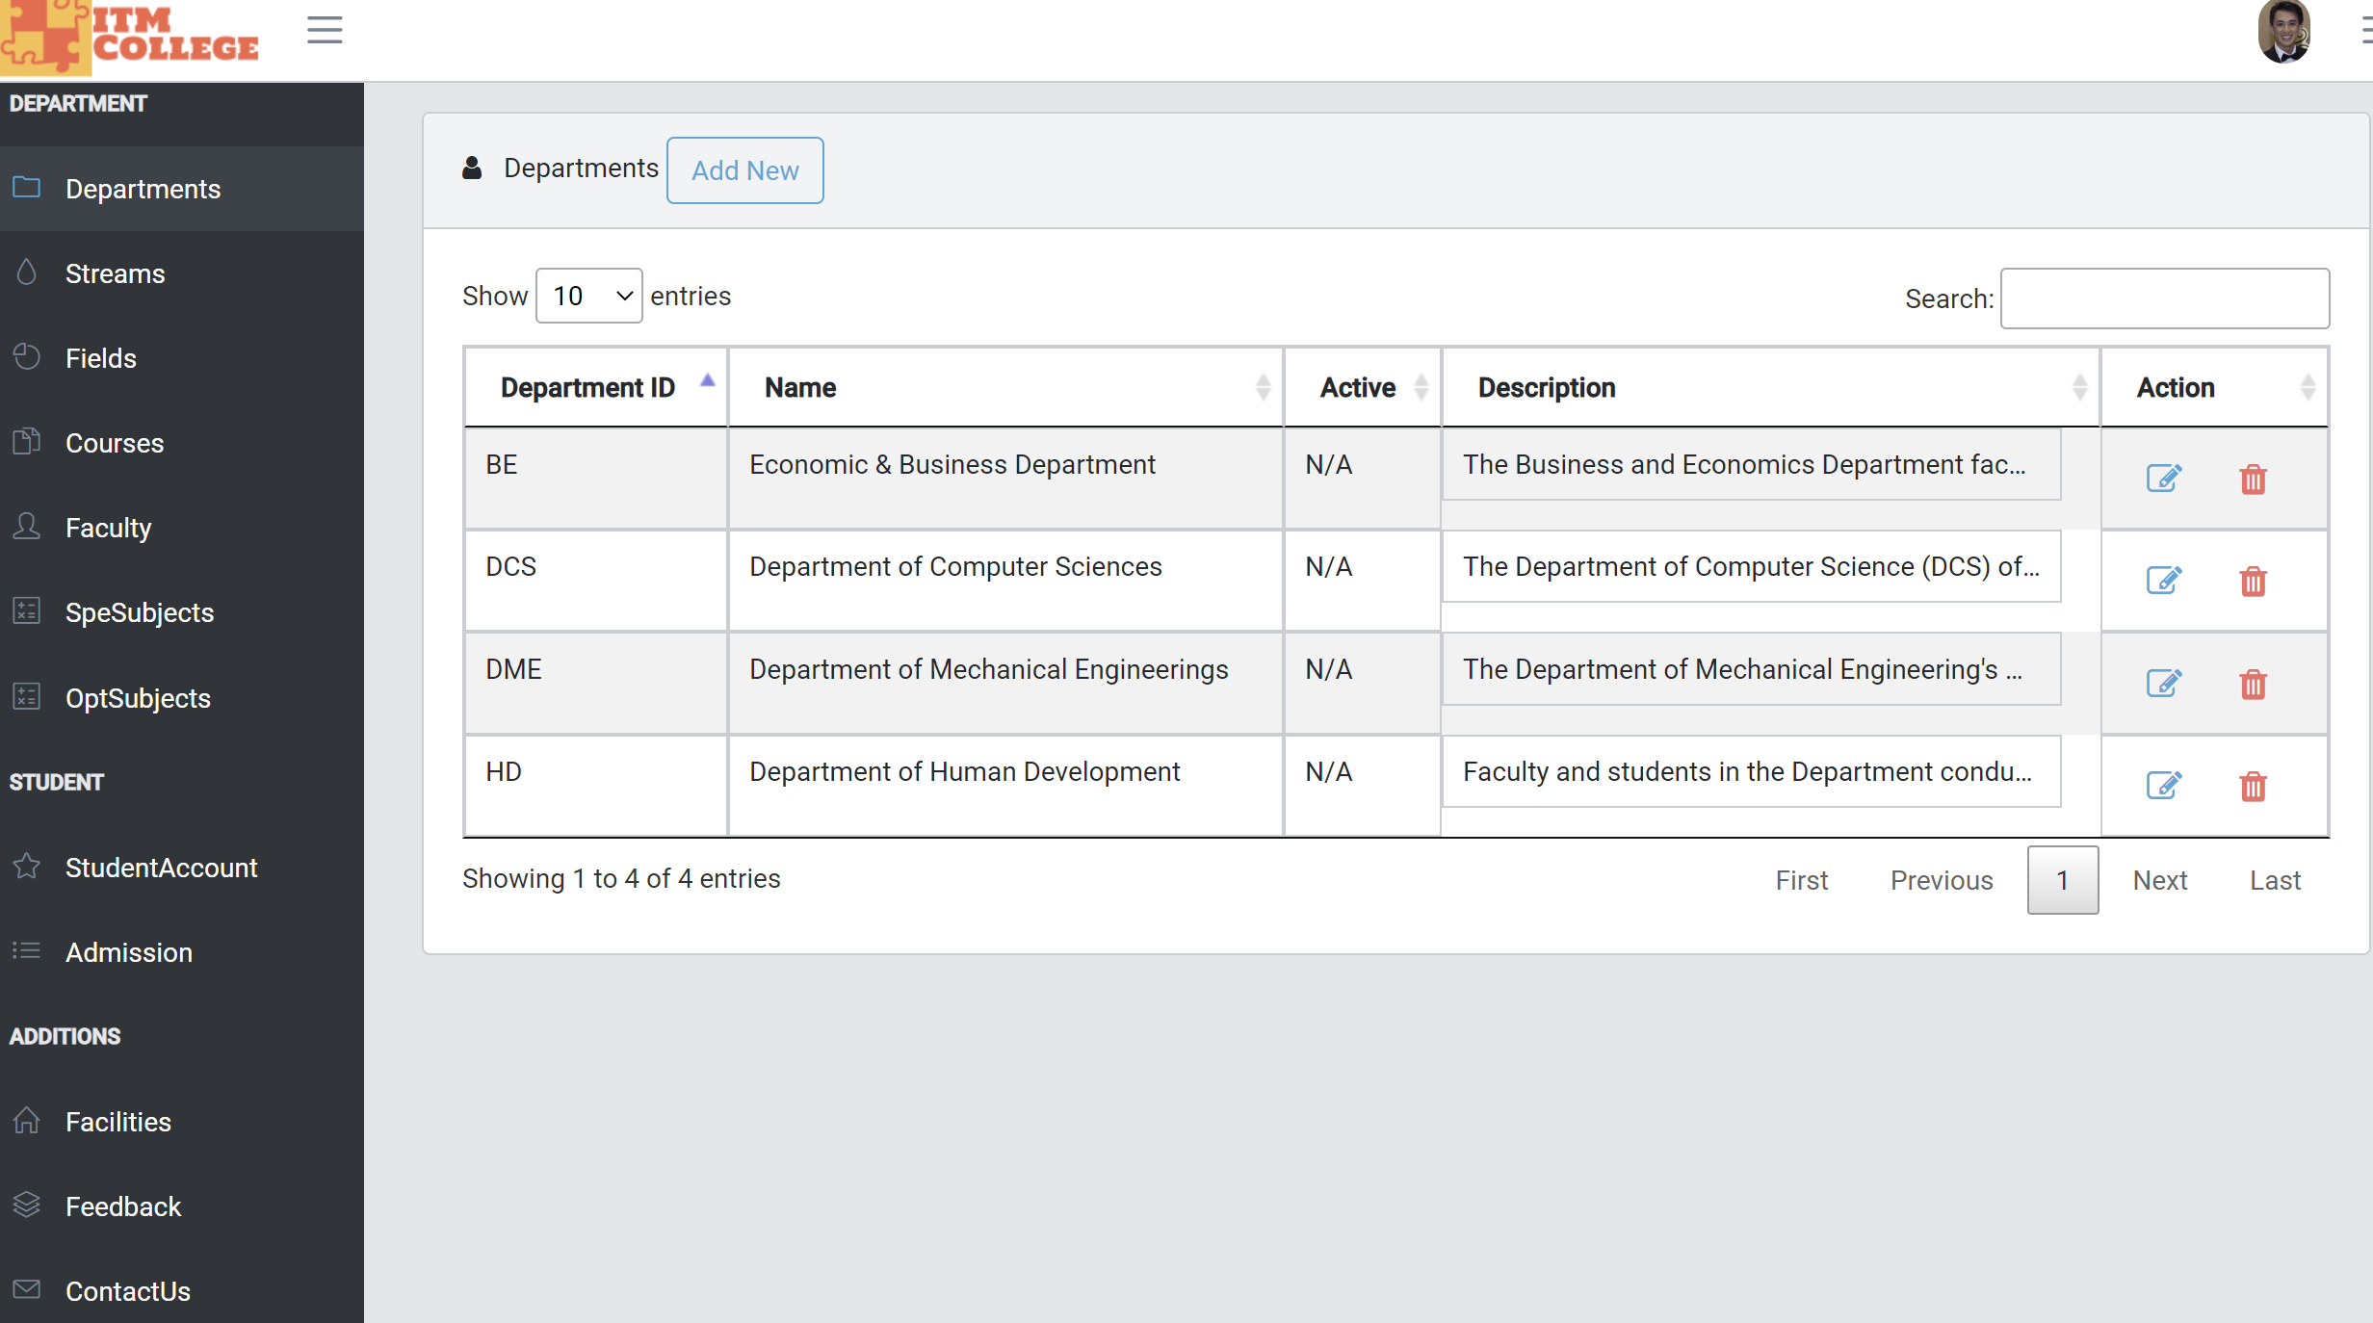

1. Department Add

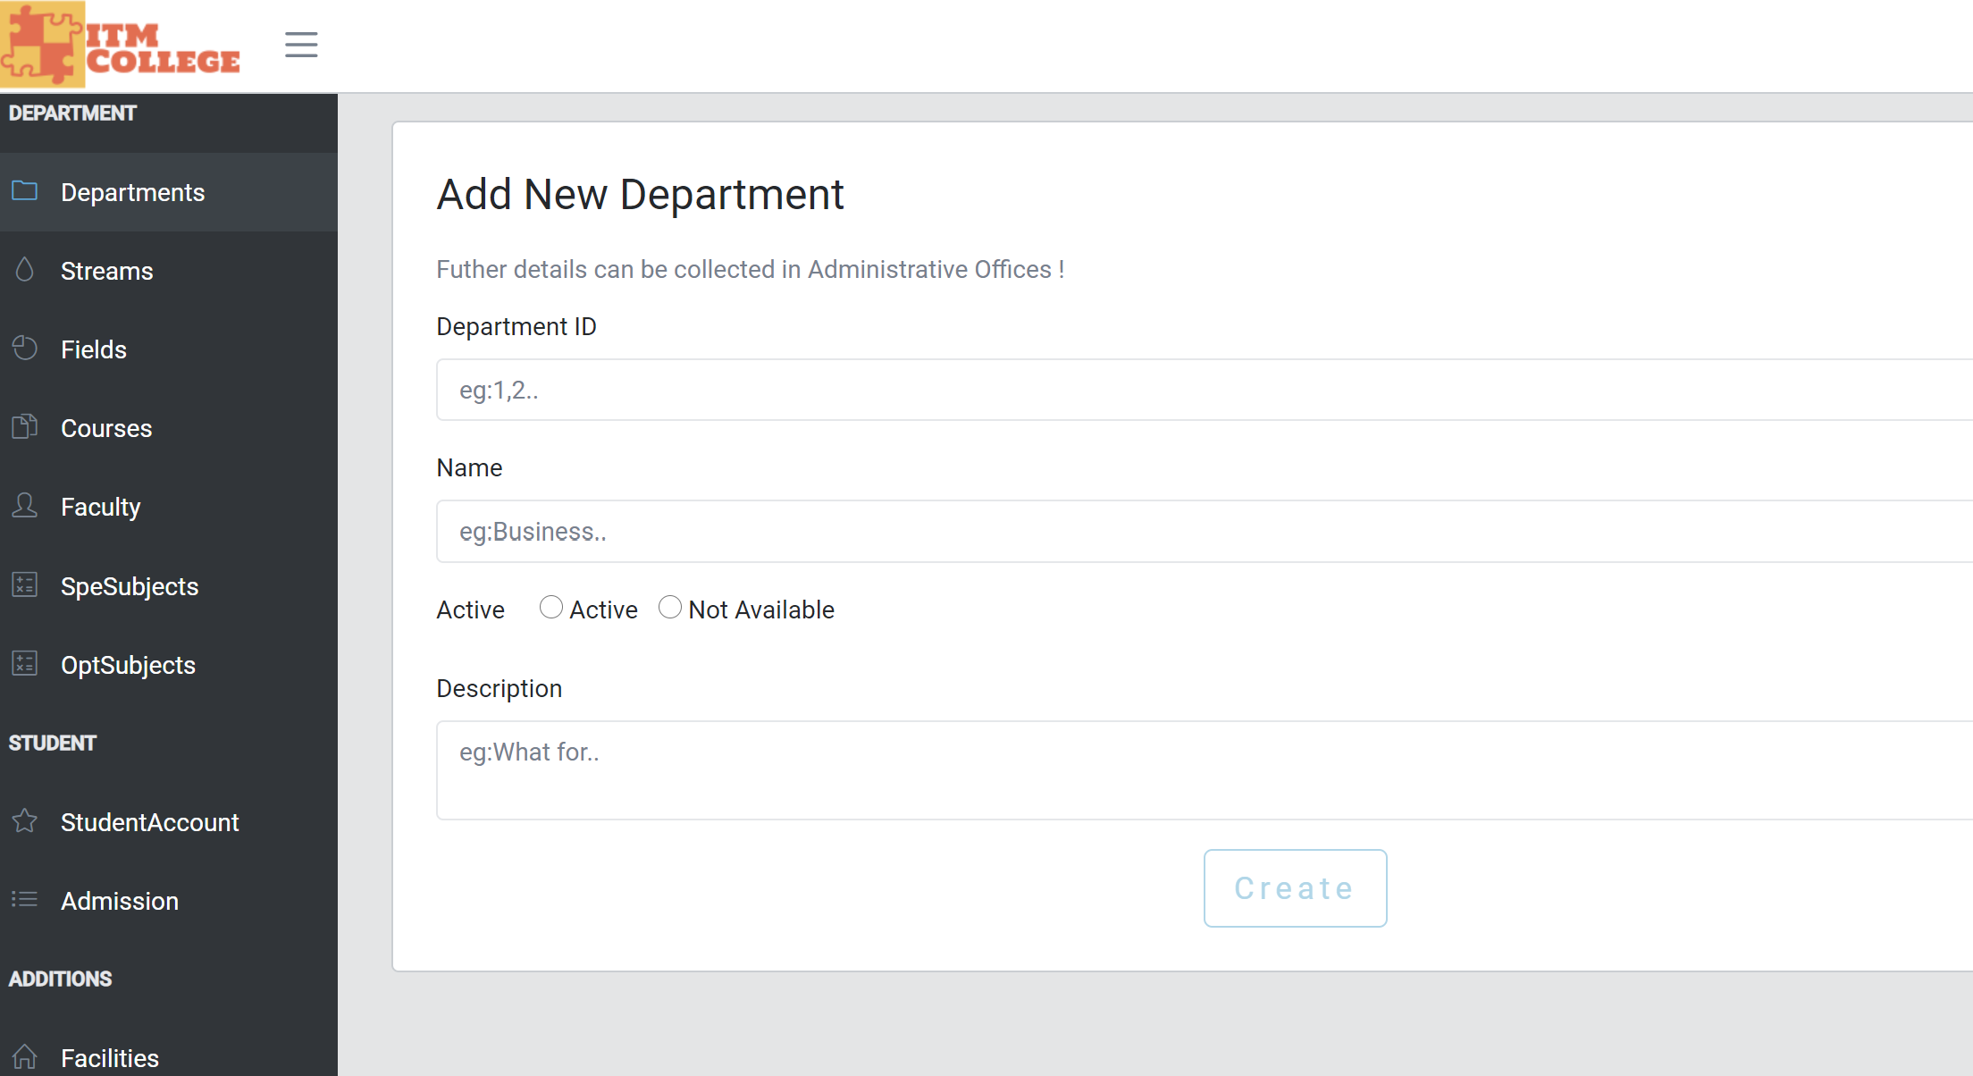

1. Facilities Management
2. Facilities List

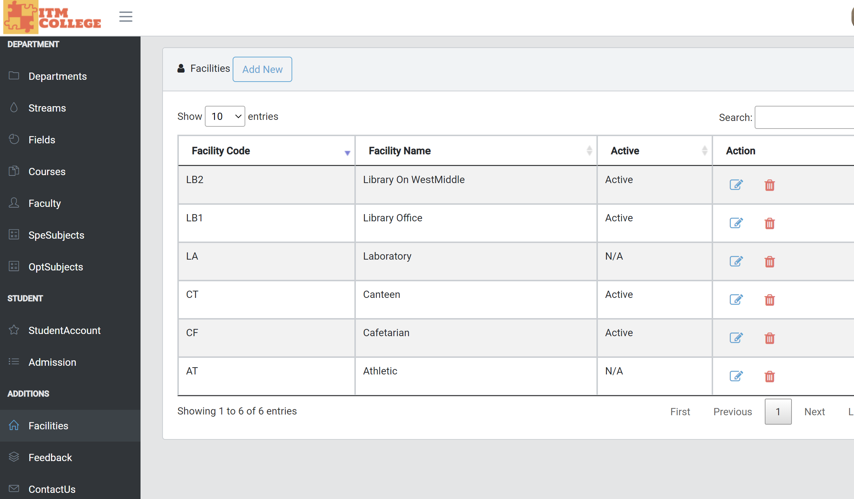

1. Facilities Add

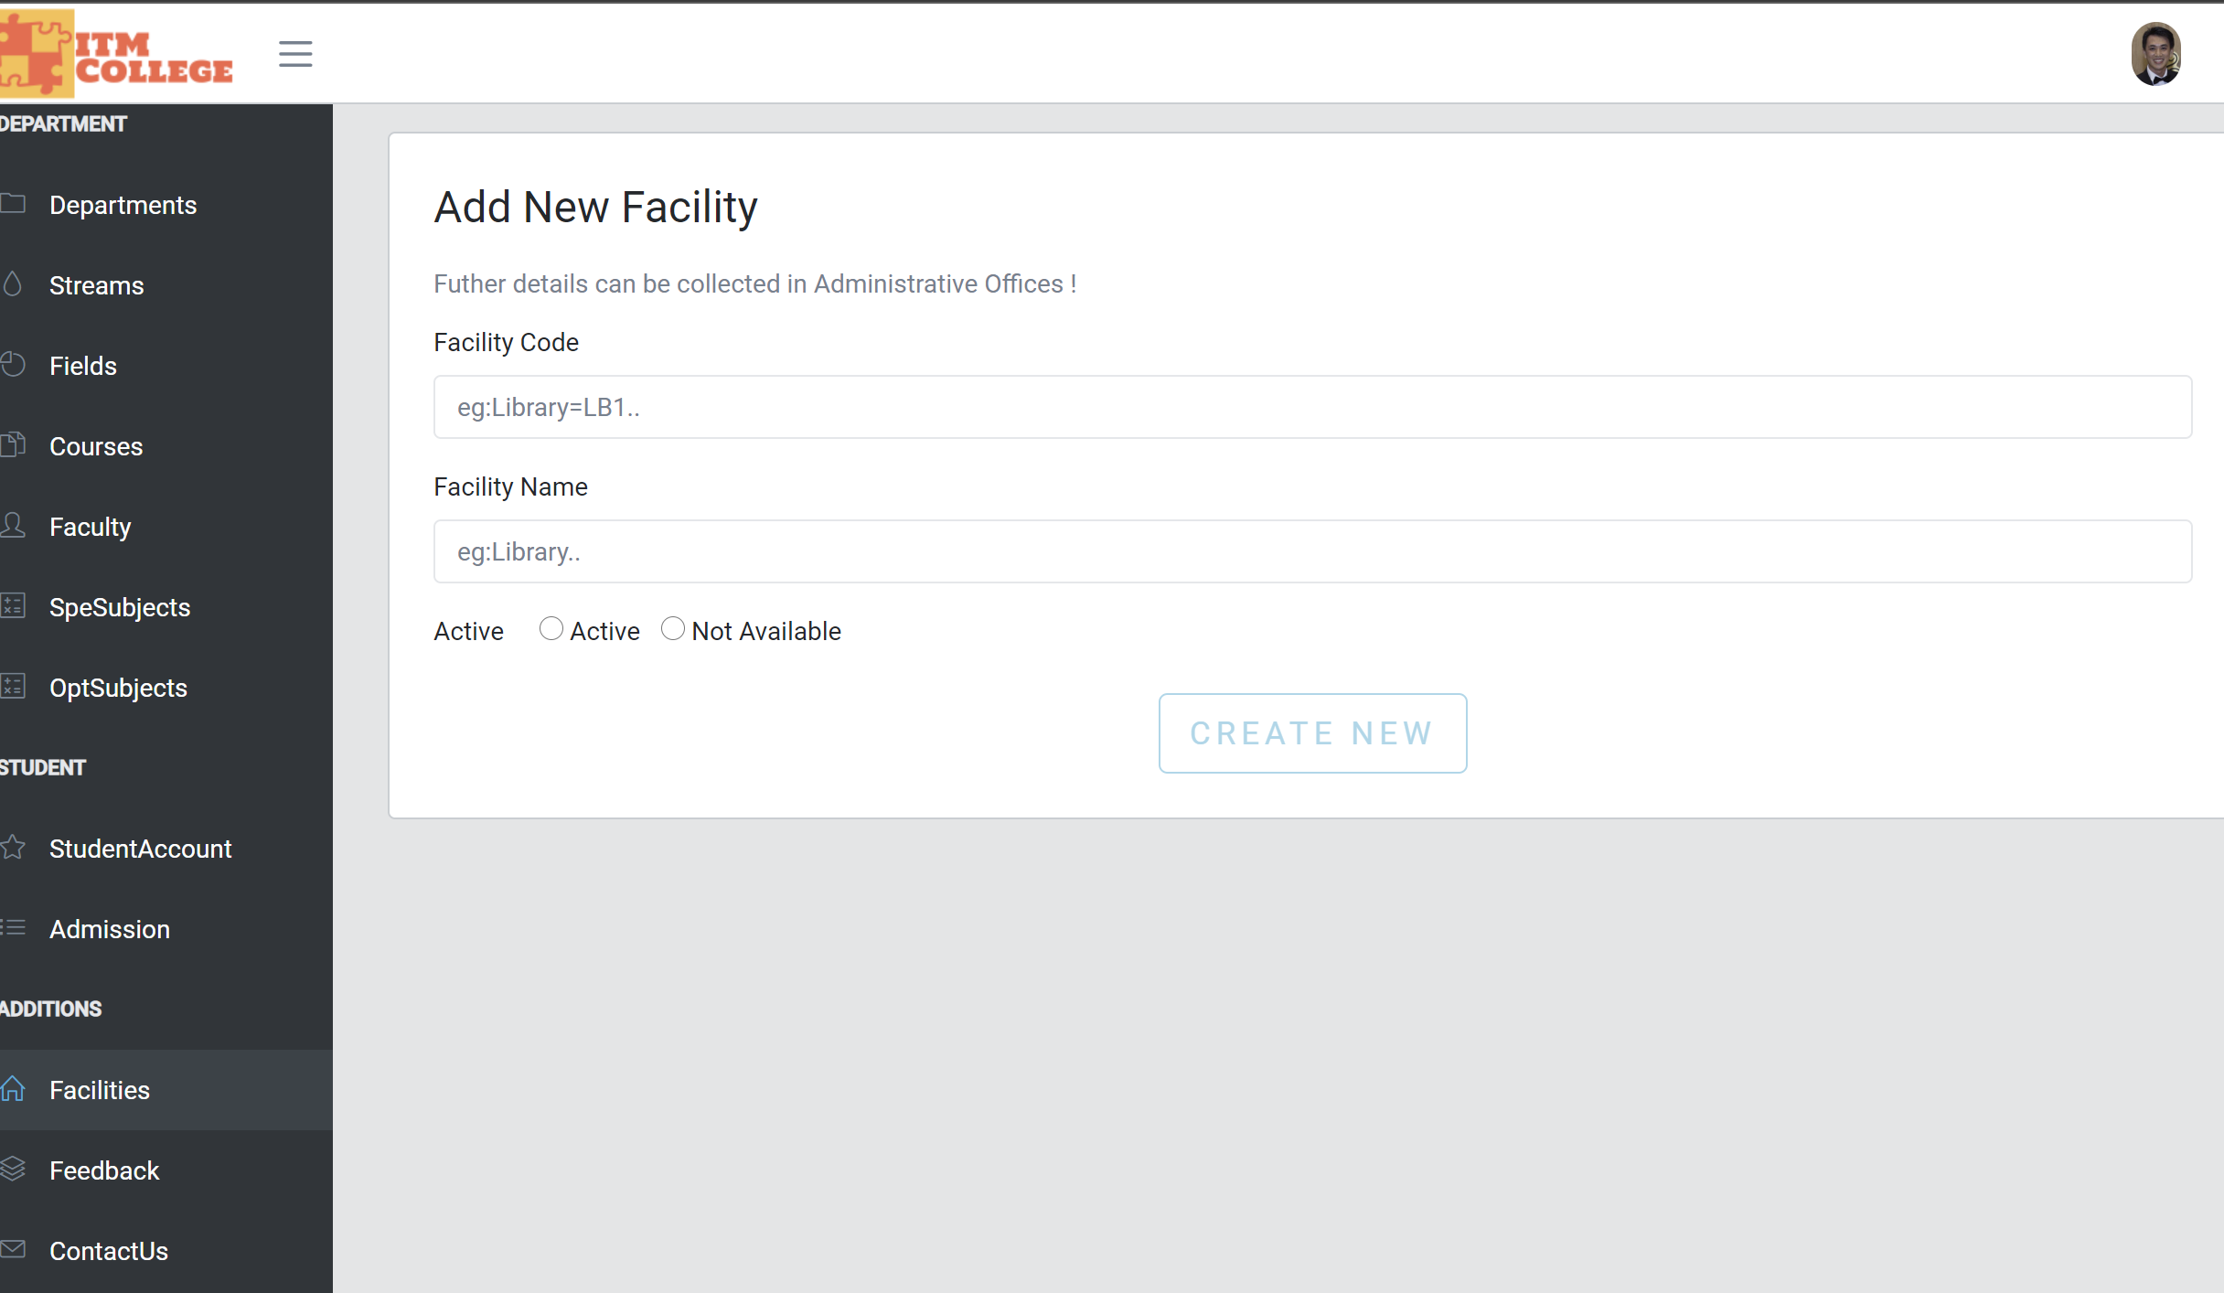

1. Facilities Edit

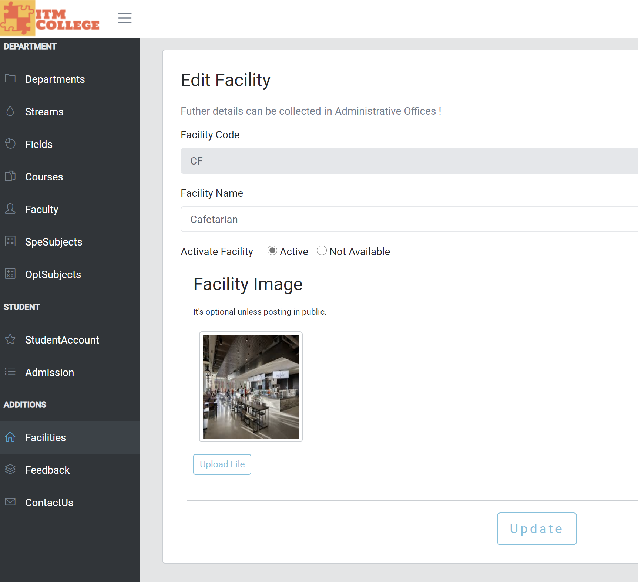

1. Student Account Management
2. Account List (user)

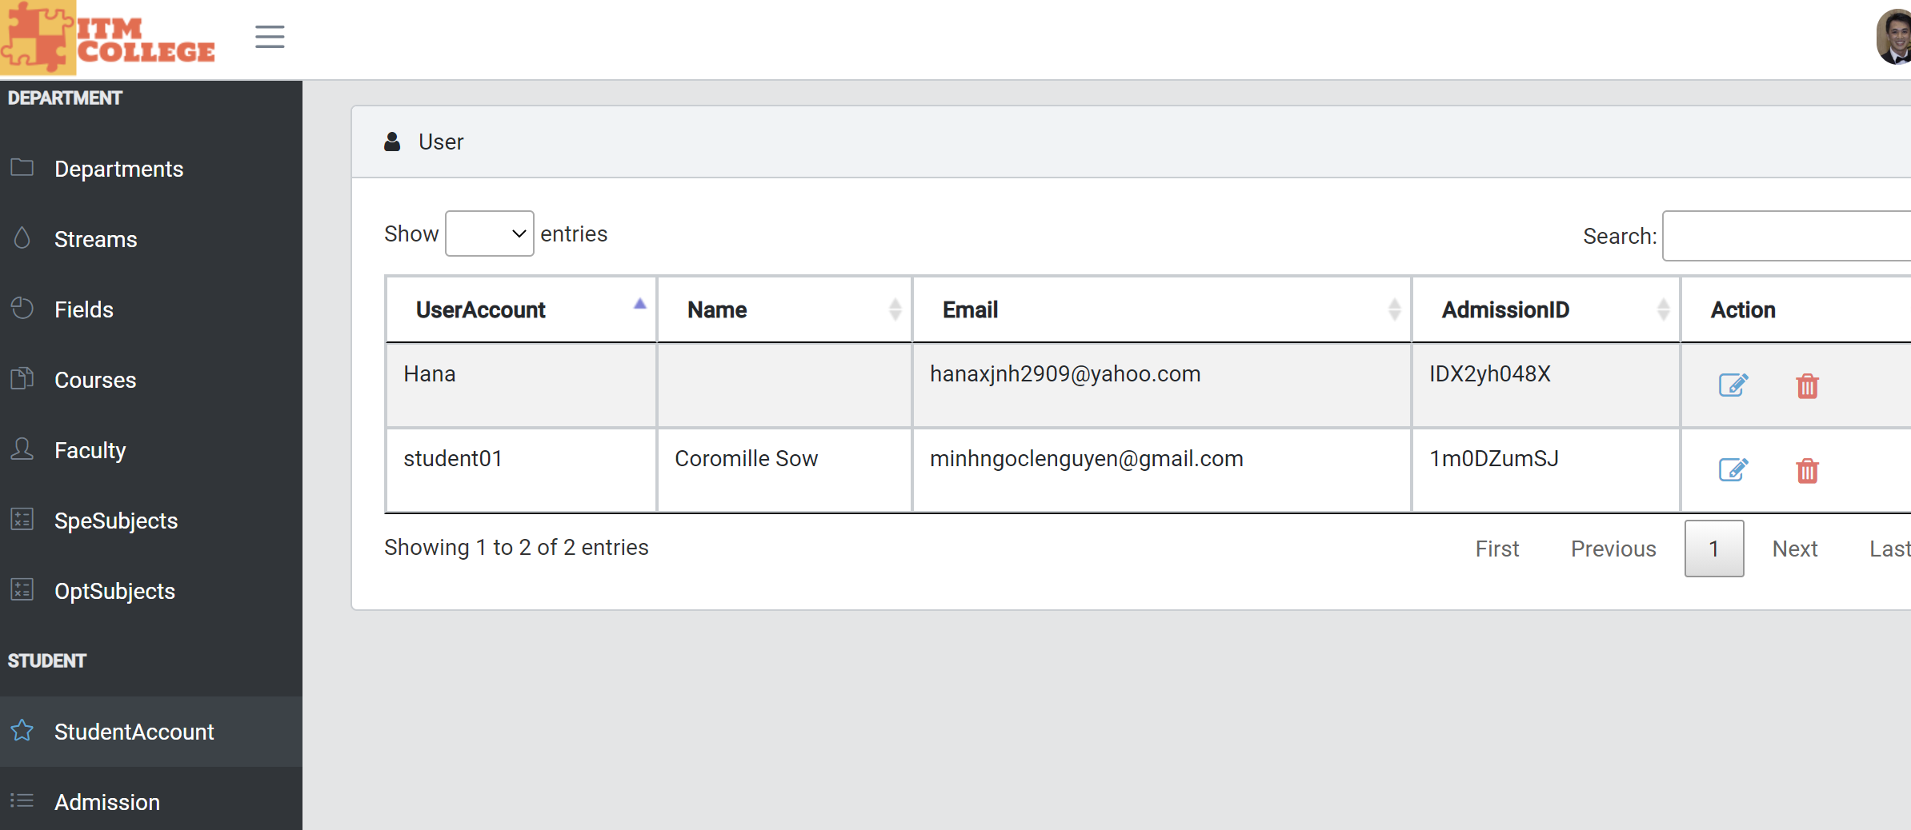

1. Account Edit

